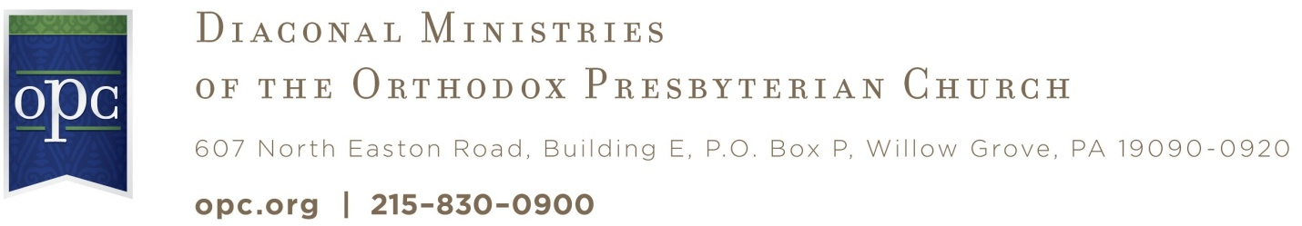

August 28, 2009

Greetings in the Name of our Good Shepherd.

I trust you have seen the advance notice of the National OPC Deacons’ Summit, planned for June 3-5, 2010, at Wheaton College, Wheaton IL? It’s been in New Horizons and your church should have received brochures. In a desire to serve the denomination to equip men to serve better as deacons, The Committee on Diaconal Ministries is sponsoring a summit for deacons in the OPC. While this summit is open for all ordained men, we hope that especially deacons and men who serve on presbytery diaconal committees will attend.

We are asking for your help and input. The desire is for this summit to be a time for deacons to learn, to express their needs, to make networks for resources, and to be renewed with a vision of the biblical importance of this holy office. We desire the diaconal committees of presbyteries to see again their calling and role to serve the churches, and also to network with other presbyteries. The calling of deacon will be addressed on the local and presbytery levels, in home congregations as well as foreign missions contexts. There will be time for instruction, as well as for open discussions and time to learn from one another. And that’s where we would appreciate having your input. Would you please forward the attached questionnaire to your deacons? We would like to include their thoughts and concerns into the program of the summit, and especially gear the workshops to address their needs.

1. Could you please electronically forward this questionnaire to your deacons?

2. We would encourage their reply to be soft copy for ease of collating responses.

3. Please send the responses back to me. The email address to use is churchofthecovenant@earthlink.com
Note: do not send your reply to the denomination’s office.

4. Please send your responses before September 30.

Please remember to enroll now. Enrolling on-line is preferred. If you need more fliers, please let the OPC office know and we will be pleased to send them to you. It’s free! The Committee on Diaconal Ministries is underwriting the cost of the summit for ordained men in the OPC (There is a nominal fee for non-OPC men). All room and board expenses are covered. The only cost to be incurred would be the travel, which cost we would encourage the local deacon boards to cover for their deacons who attend.

If you have any questions, please let contact me or David Haney, at the OPC offices. Please remember this summit in prayer? We desire to see the Lord’s richest blessing on this time together. Thank you for your appreciated help with this questionnaire.

For the Committee,

Rev. Ronald E Pearce
Secretary CDM

______________________________________________________________________________________________________________

Correspondence or Inquiries

Committee on Diaconal Ministries
Rev. Ronald Pearce, Secretary
Church of the Covenant
319 Blau Road
Hackettstown, NJ 07840-5227
Phone: 908-850-8910
Email: churchofthecovenant@earthlink.net
Financial Contributions

Orthodox Presbyterian Church
Committee on Diaconal Ministries
Box P
Willow Grove, PA 19090-0920
Phone: 215-830-0900

Please be sure to clearly designate contributions.

